Make Leaf Puppets - quick, easy and great fun!
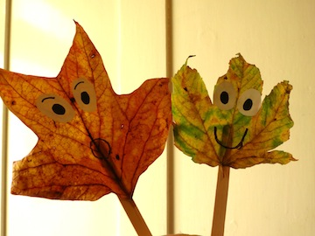
You will need:
Popsicle sticks - as many as the number of puppets you want to make.
Autumn leaves - dry enough to hold their shape but not all dry and crinkly!
Glue
White paper
A black marker
1. Choose a variety of nice leaves that you want to use as your puppets. You can make as many as you like!
2. Cut out two ovals from white paper for the eyes and color the middle in black. Draw on a mouth if you like.
3. Glue the eyes onto the top of the leaf and glue a popsicle stick behind. Hold it down firmly to dry.
TIP: Why not make a whole collection of these puppets. Kids love imaginative play and could use these are little characters in a story!

Make Cut Out Leaves
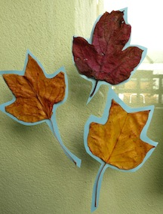
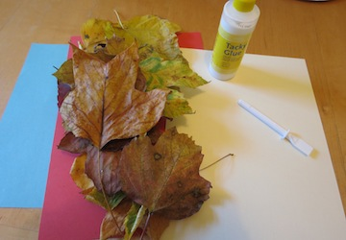
You will need:
Colored paper or cardstock
Glue
Scissors
A range of autumn leaves.
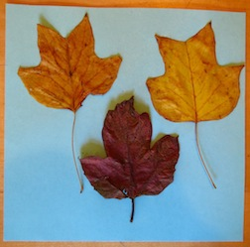
2. Stick a number of different leaves onto your chosen card. Let them dry. Then take your scissors and cut round the leaves leaving a small border of card showing.
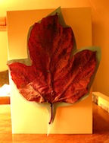
Stick them to a window or mount them on more card stock to make card.

